Module 2 | R Outputs

Pei-Yu Jheng (Chloe)

ALY6010 Probability Theory and Introductory Statistics Instructor: Dr. Mimoza Dimodugno

November 12, 2023

**Introduction and Process**

“Virtual Reality Experiences Dataset” was chosen for this Module 2 R practice. The dataset is related to user satisfaction with a virtual reality (VR) experience from Kaggle. The dataset contains information on “physiological responses, such as heart rate and skin conductance, emotional states, and user preferences,” given by a sample of 1000 users who experienced the VR applications (Joshi, 2023). Each user involved in the VR experience is represented in each row. The variables of interest are the Motion Sickness Rating (measured on a scale from 1 to 10), higher values are, indicate a higher level of motion sickness that will cause customers to feel uncomfortable; Immersion Level (measured on a scale of 1 to 5), 5 refers to the strong immersive feeling that users feel in a VR environment; the duration time of the VR game; and the VR headset device they experienced are using in order to gain a deeper understanding of user satisfaction all in the dataset. The objective is to assess the average satisfaction rating among all potential users of a VR application by evaluating the existing user experience

**Table 1**

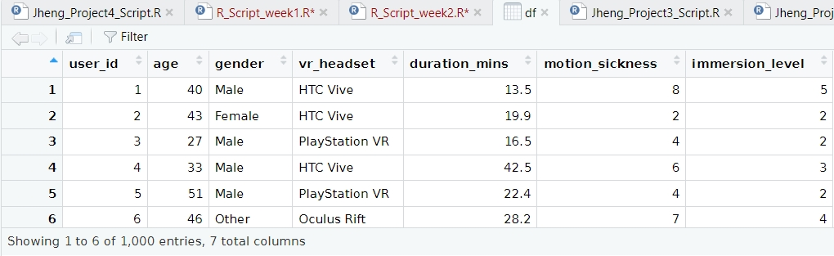

**Descriptive Statistics Tables**

***Descriptive Statistics Table 1:*** using summarytools::descr and psych::describe functions to obtain descriptive statistics for the entire sample.

**Table 2**

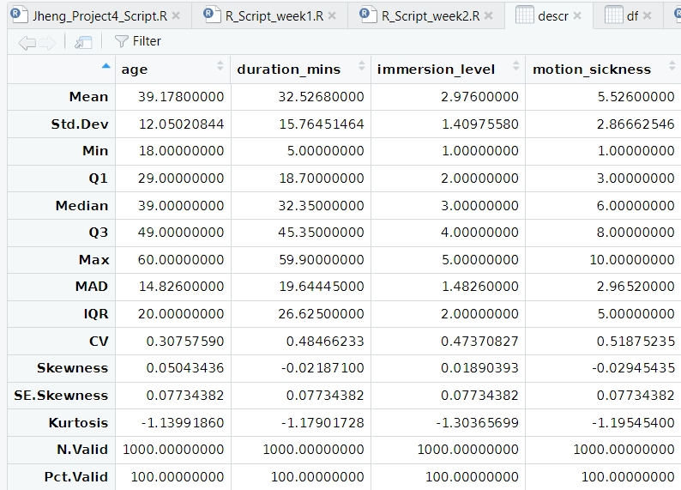

**Figure 1**

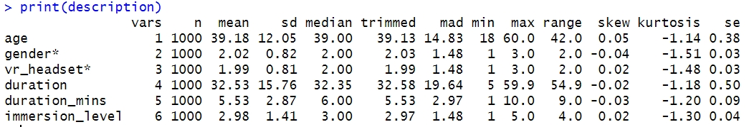

***Analysis***

In Table 2, the non-numerical variables of gender and VR headset have been ignored; in Figure 1 those two variables are still present but do not have meaning. Through these descriptive statistics tables, we have a few interesting findings. Firstly, the age range in this dataset is 18 to 60. The average age (39.17) is almost the same as the median (39 years old) which indicates the age distribution of the VR experience dataset is a “perfectly symmetrical distribution” (Illowsky & Dean, n.d.). This will lead to the age distribution being concentrated in the middle-aged age range, which may mean that this data set is more representative of the VR experience of middle-aged people. This may make sense for developing and marketing VR applications targeted at middle-aged adults. Here is the histogram that proves my conclusion above:

**Figure 2**

Secondly, the Immersion Level Scale ranges from one to five, and the Motion Sickness Rating is on a scale from one to ten. The average immersion level in this dataset is below three, with a median of three. This suggests that, on average, users have given lower ratings for the immersion experience, indicating a relative dissatisfaction. Additionally, the average motion sickness rating is higher than five, with a median of six, indicating that, on average, users have given higher ratings for the motion sickness experience, suggesting relative dissatisfaction, potentially caused by discomfort from the VR headset.

The data suggests that, from a business perspective, there are areas in the VR experience that need improvement. Users, on average, have expressed dissatisfaction with both the immersion level and motion sickness aspects. Lower immersion ratings may indicate that users find the overall experience less engaging or immersive. Additionally, higher motion sickness ratings could signal discomfort, potentially hindering overall user satisfaction with the VR headset. Addressing these concerns and enhancing both the immersion and comfort aspects of the VR experience could lead to increased user satisfaction, improved product perception, and potentially better business outcomes in the virtual reality market. To better understand overall satisfaction, it is essential to consider the distribution of ratings in the following, as well as potential factors influencing users' perceptions if possible.

***Descriptive Statistics Table 2:*** Using dplyr and summarytools packages to generate descriptive statistics tables by group for more detailed tables.

**Figure 3 – The code used**

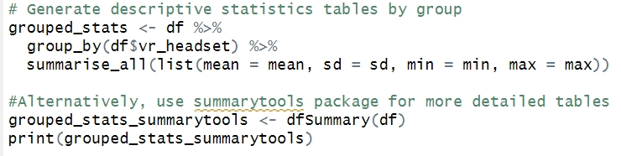

**Table 3**

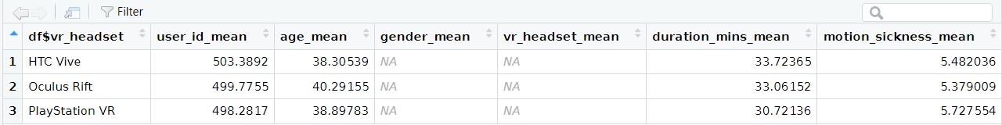

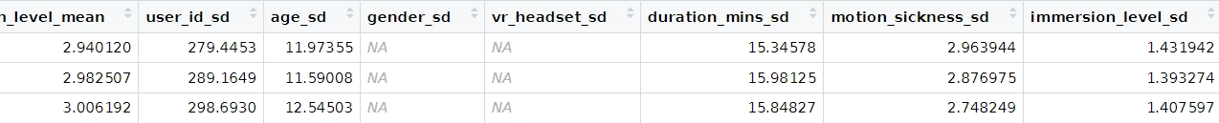

**Figure 4**

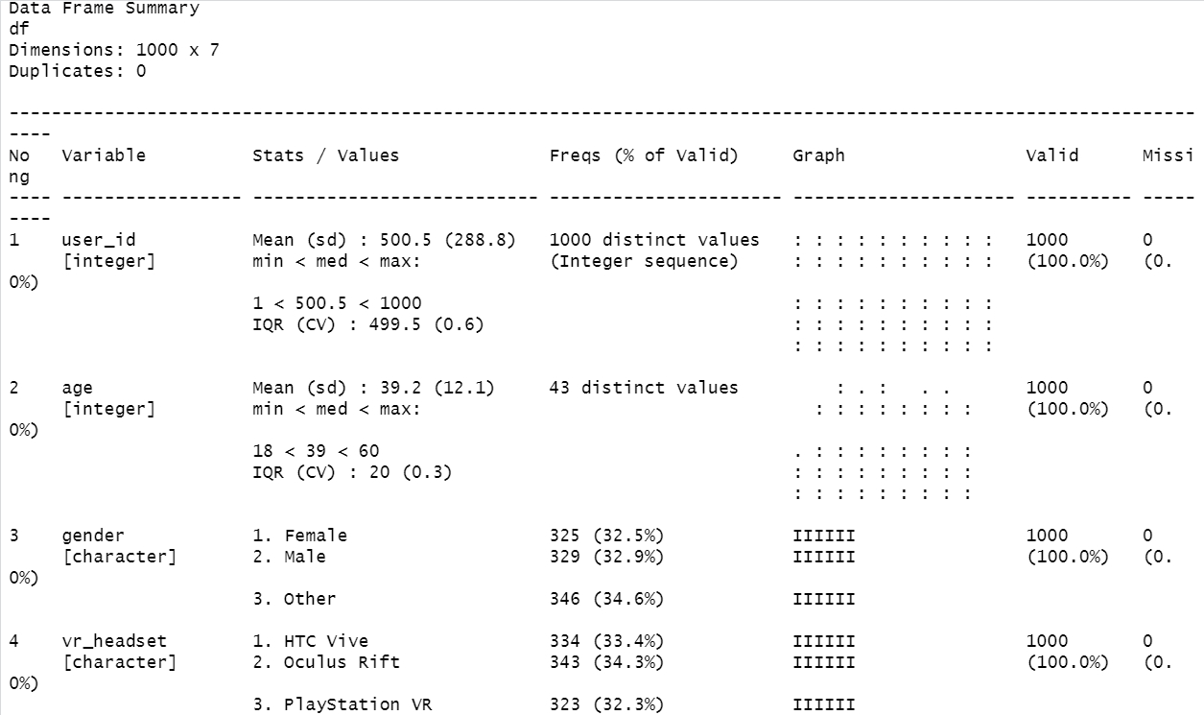

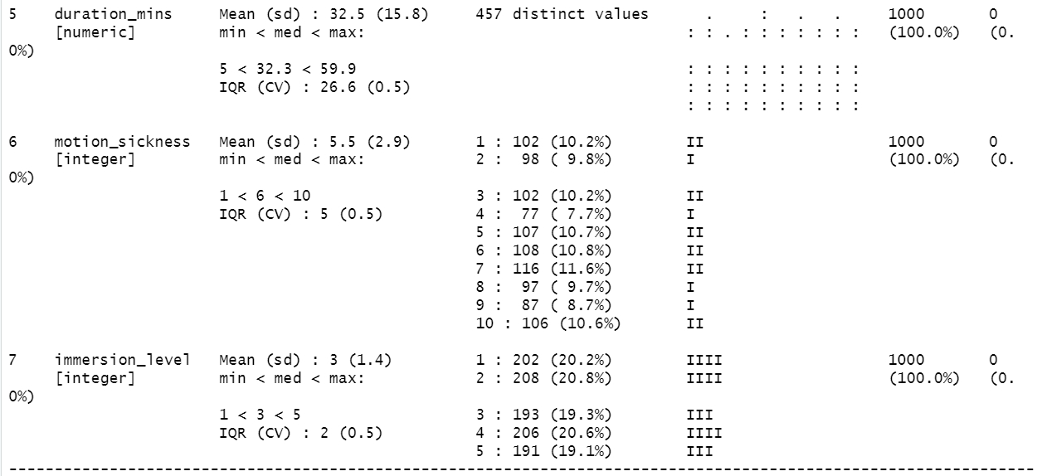

***Analysis***

According to the detailed distribution of Immersion Level, about 40.5% of users (202 people + 208 people) gave a low score of 1 or 2, showing that users in this group feel a lower sense of immersion; relatively, according to the detailed distribution of Motion Sickness, about 41.5% of users (116 people + 97 people + 87 people + 106 people) gave a higher score of 7 to 10, showing that users in this group have a more obvious feeling of motion sickness discomfort sense. It may lead to dissatisfaction with the overall immersion. The distribution of these two sets of scores strongly confirms the previous analysis, highlighting that there may be certain contradictions in the feelings of immersion and motion sickness in VR experiences among different user groups. Again, this provides valuable insights into improving the VR experience and increasing overall user satisfaction.

In terms of gender and VR headset device distribution, they are all very evenly distributed. This balance is important for ensuring that insights or models trained on the dataset can be applied to a diverse range of users and VR devices, it helps avoid biases that might arise if certain gender groups or VR headset types were overrepresented or underrepresented in the dataset and minimizes the risk of overrepresenting or underrepresenting specific demographic groups, allowing for more robust generalizations. This can contribute to more reliable and unbiased results. Therefore, the analyses derived from a dataset with an even distribution of gender and VR headset types in a dataset are generally considered positive as they enhance the dataset's representativeness, generalizability, fairness, and applicability. Moreover, it reduces the risk of bias in analyses and applications related to virtual reality.

**Three-line Table of VR Headset Comparison**

**Table 4**

|  |  |  |  |
| --- | --- | --- | --- |
| Headset Device | HTC Vive | Oculus Rift | PlayStation VR |
| Motion Sickness Rating Mean | 5.48 | 5.37 | 5.72 |
| Immersion Level Rating Mean | 2.94 | 2.98 | 3.00 |

***Interpretation:***

This is a brief comparison table of virtual reality (VR) headsets, providing evaluations of three VR headset devices with average motion sickness score, and average immersion score. Here is an explanation of each: These numbers represent the level of average motion sickness scores when using different VR headsets. Higher ratings generally imply that users are more susceptible to motion sickness. Here, the PlayStation VR headset has the highest rating of 5.72, indicating a slightly higher potential for inducing motion sickness compared to HTC Vive (5.48) and Oculus Rift (5.37). Regarding immersion levels, the numbers reflect how well different VR headsets provide user immersion. Lower ratings may indicate that users feel less engaged and immersed in the virtual experience. In the table, the three devices score relatively close, with not much difference. However, the PlayStation VR is slightly higher than the other two with a rating of 3.00, closely followed by Oculus Rift (2.98), while HTC Vive scores slightly lower at 2.94, possibly meaning it is slightly better in terms of immersion.

According to the data, PlayStation VR is relatively high in motion sickness and slightly higher than the other two in terms of immersion. Companies can emphasize PlayStation VR's superiority in terms of immersion while working to improve motion sickness performance to increase overall competitive advantage. The R&D team can focus on developing innovative technologies and improving hardware or software to alleviate this problem

**Exploratory Data Analysis**

**#Question 1:** **Are youngers more tolerant of motion sickness while experiencing VR?**

Model: (1) Calculate the average motion sickness score for each age using the dplyr package (2) Create a jitter chart of the relation between age and motion sickness rating.

**Figure 5**

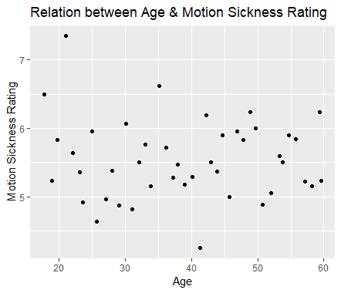

***Analysis***

Each dot represents the average Motion Sickness Rating of each age. There are two interesting outliers to point out that my assumption is wrong. 21-year-old people's average motion sickness rating is 7.35, which indicates the highest motion sickness has been felt among all users; 41-year-old people’s average motion sickness rating is 4.25, which demonstrates the lowest motion sickness this group of people felt compared with others. Moreover, there are not relatively strong or low ratings among all users; therefore, age has nothing to do with Motion Sickness feeling. While the results noted significant extremes in motion sickness scores in the two age groups of 21 and 41, they also noted that there was no clear age-related trend among all users. This emphasizes a critical point, that is, when a company improves motion sickness, it will not only benefit a specific group of people but will improve the overall user experience. This allows the contribution of the R&D team to achieve greater benefits, not just limited to a certain group of people

***#Question 2:*** box plot of device and Motion Sickness

**Figure 6**

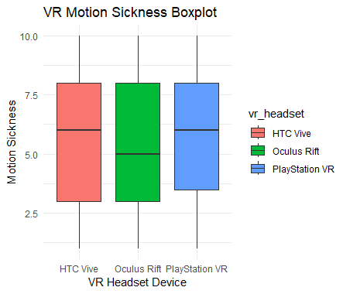

***Analysis***

When we look at the number of quarterbacks above and the number of quarterbacks below, PlayStation VR’s users report higher discomfort than the other devices while the other two devices are likely. In terms of the median of three headsets, Oculus Rift has a relatively low review of Motion Sickness discomfort. In conclusion, due to the second high immersion level rating mean result in the previous three-line table analysis and the box plot showing that Oculus Rift caused less motion sickness which is more competitive than the other two devices, Oculus Rift is positioned as a leading choice for users seeking an immersive virtual reality experience with a favorable balance between high immersion and reduced motion sickness. This dual advantage enhances Oculus Rift's appeal in the VR market, providing users with an enjoyable and comfortable virtual reality environment.

**#Question 3: How does the VR experience time influence user immersion ratings?**

**Figure 7**

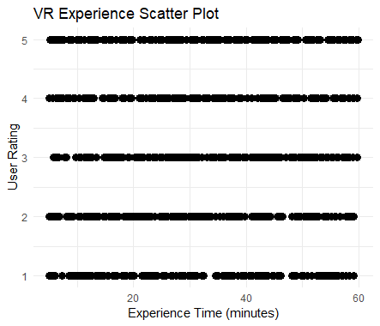

***Analysis***

There is no specific correlation between time and immersion experience from the scatter plot. Each score is almost evenly distributed at distinct experience times. Therefore, we can conclude that time has no significant impact on the immersion experience.

Reference

Illowsky, B., & Dean, S. (n.d.). Skewness and the mean, median, and mode | Introduction to statistics. https://courses.lumenlearning.com/introstats1/chapter/skewness-and-the-mean-median-and-mode/

Joshi, A. (2023, May 18). *Virtual Reality experiences*. Kaggle. https://www.kaggle.com/datasets/aakashjoshi123/virtual-reality-experiences